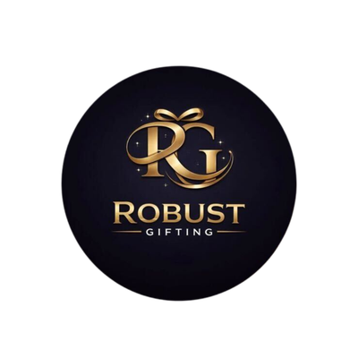
Water Bottle Catalogue
Robust Gifting | Premium Corporate Gifting Solutions
52 Premium Designs | Prices exclusive of 18% GST

Item No. 01  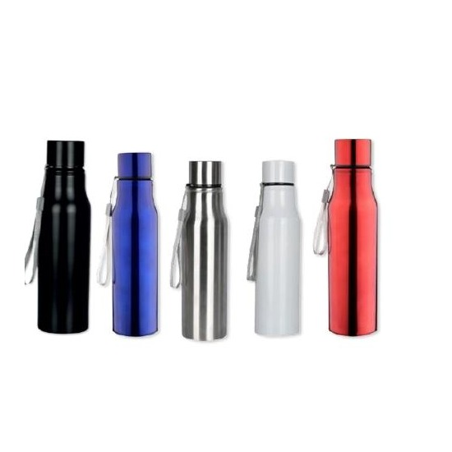  Stainless Steel Water Bottle  Stainless Steel | 750 ml  Sleek stainless steel bottle in 5 vibrant color options  ₹100 |  | Item No. 02  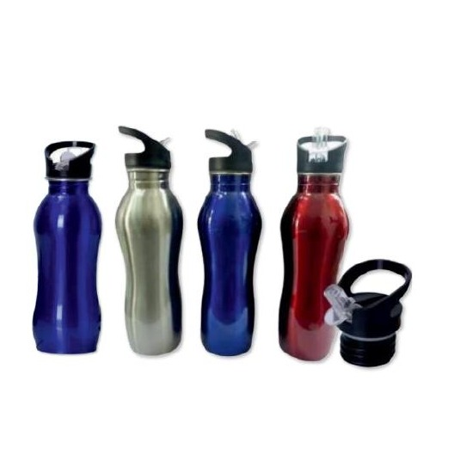  Stainless Steel Flip-Cap Bottle  Stainless Steel | 750 ml  Curved stainless steel bottle with flip-top cap, multiple colors  ₹125
Item No. 03  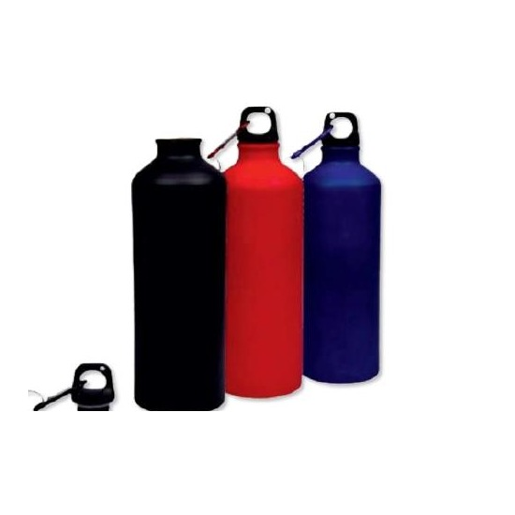  Aluminium Water Bottle  Aluminium | 750 ml  Lightweight aluminium bottle available in vibrant solid colors  ₹90 |  | Item No. 04  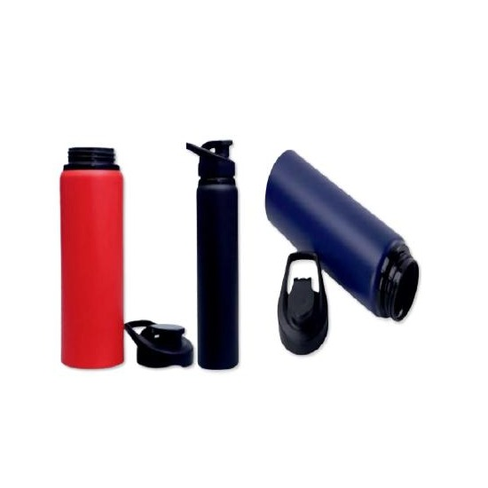  Aluminium Metal Bottle  Aluminium | 750 ml  Matte-finish aluminium metal bottle with carabiner clip attachment  POA
Item No. 05  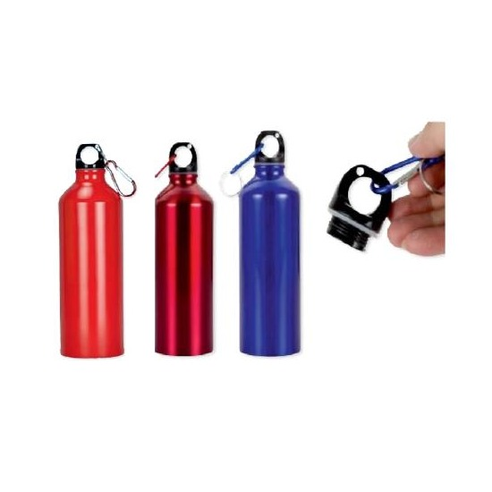  Aluminium Metal Bottle  Aluminium | 750 ml  Classic aluminium metal bottle with carabiner clip, multiple shades  ₹90 |  | Item No. 06  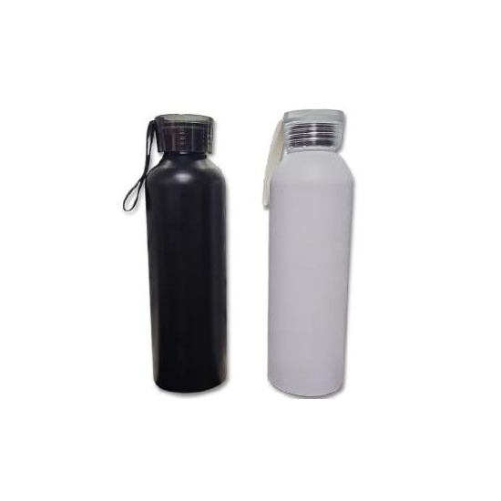  Aluminium Bottle with Silicone Caps  Aluminium | 1000 ml  Large-capacity aluminium bottle with secure silicone sealing caps  ₹95
Item No. 07  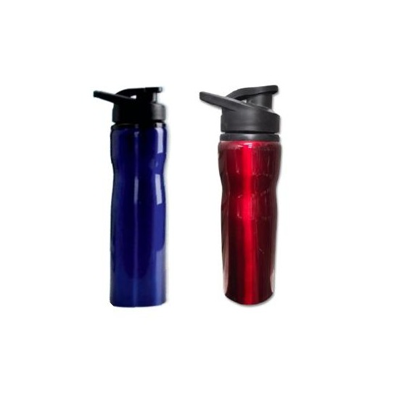  High-Grade Stainless Steel Bottle  Stainless Steel | 750 ml  Premium high-grade stainless steel bottle with flip-top lid  ₹110 |  | Item No. 08  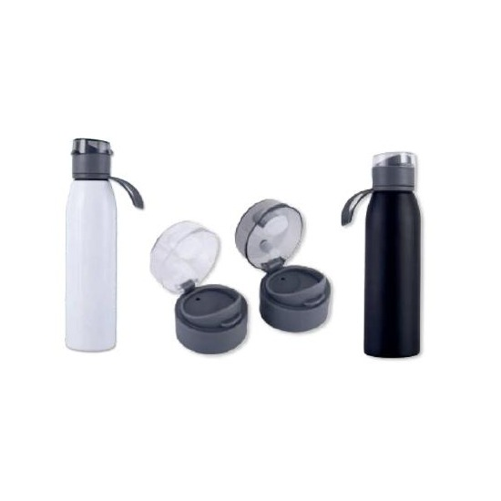  Stainless Steel Bottle with Handle  Stainless Steel | 750 ml  Functional stainless steel bottle with built-in carry handle  ₹120
Item No. 09  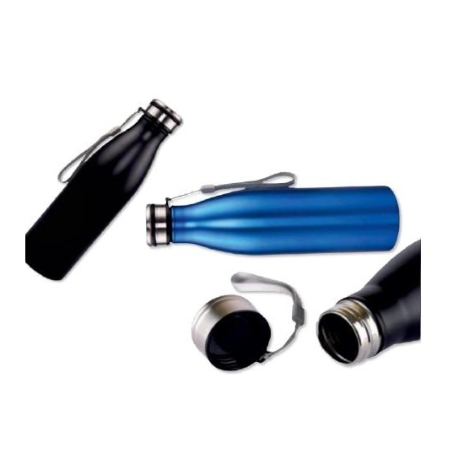  Stainless Steel Bottle with String  Stainless Steel | 750 ml  Stylish stainless steel bottle with attached carry string  ₹125 |  | Item No. 10  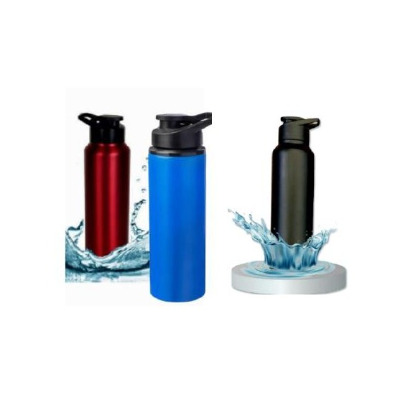  High-Quality Stainless Steel Bottle  Stainless Steel | 750 ml  Premium stainless steel bottle in assorted metallic finishes  ₹135
Item No. 11  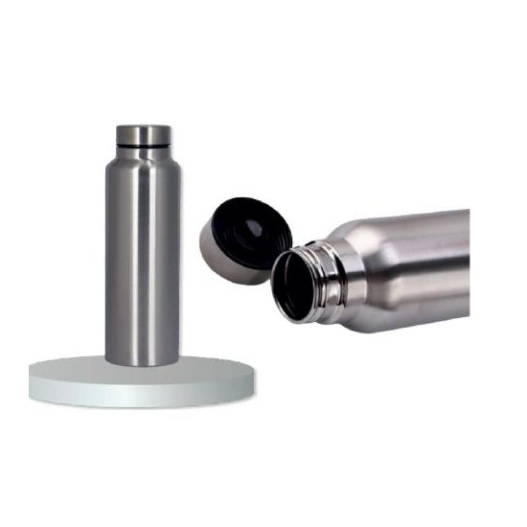  High-Grade Steel Water Bottle  Stainless Steel (High Grade) | 1000 ml  Large-capacity high-grade steel bottle, durable single-wall build  ₹95 |  | Item No. 12  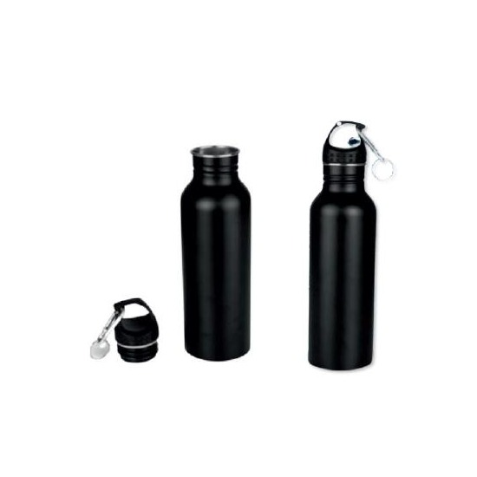  Premium Stainless Steel Bottle  Stainless Steel | 750 ml  Premium single-wall stainless steel bottle in elegant finishes  ₹125
Item No. 13  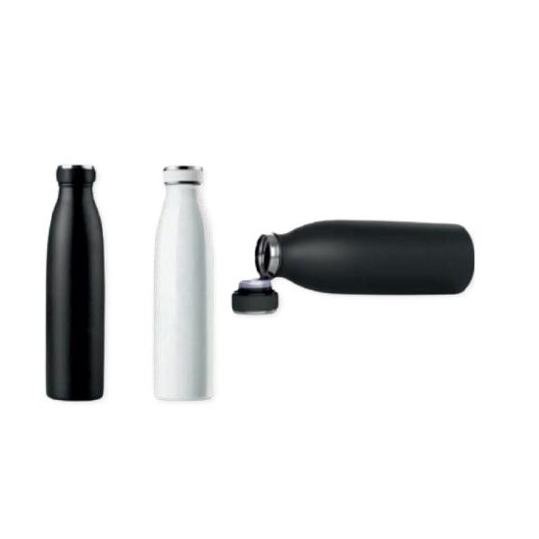  Hot & Cold Vacuum Bottle  Stainless Steel | 750 ml  Dual-purpose vacuum-insulated bottle for hot and cold beverages  ₹260 |  | Item No. 14  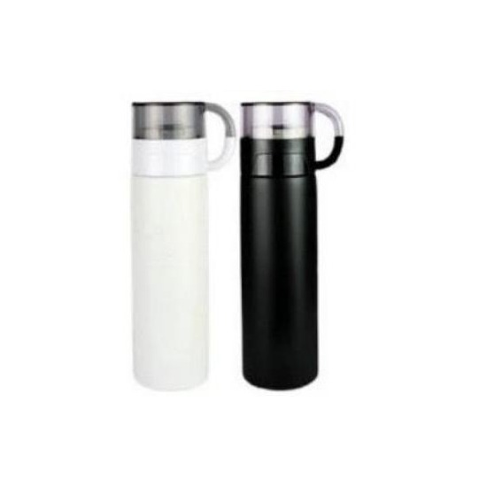  Vacuum Insulated Bottle with Cup  304-Grade Stainless Steel | 500 ml  304-grade vacuum insulated bottle with matching stainless steel cup & lid  ₹160
Item No. 15  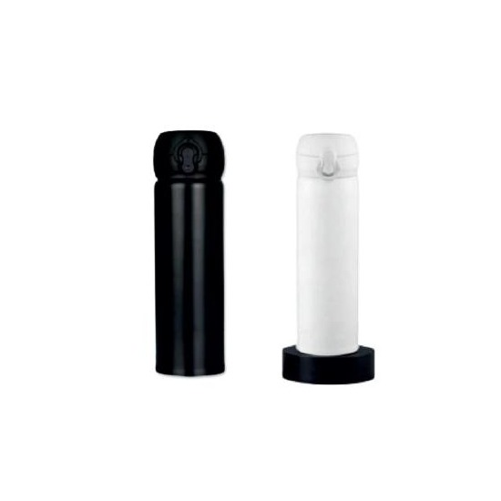  Vacuum Insulated Mug with Lock Cap  304-Grade Stainless Steel | 500 ml  304-grade vacuum insulated mug with twist-lock security cap  ₹145 |  | Item No. 16  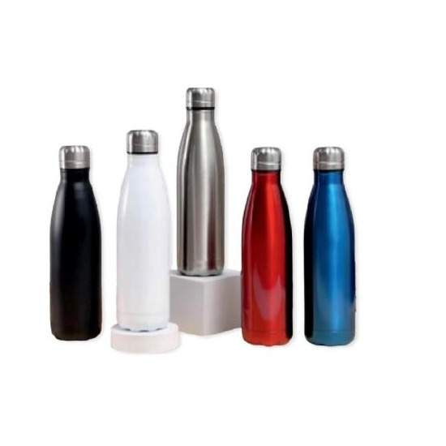  Vacuum Insulated Steel Cup  304-Grade Stainless Steel | 500 ml  304-grade stainless steel vacuum insulated cup, premium finish  ₹200
Item No. 17  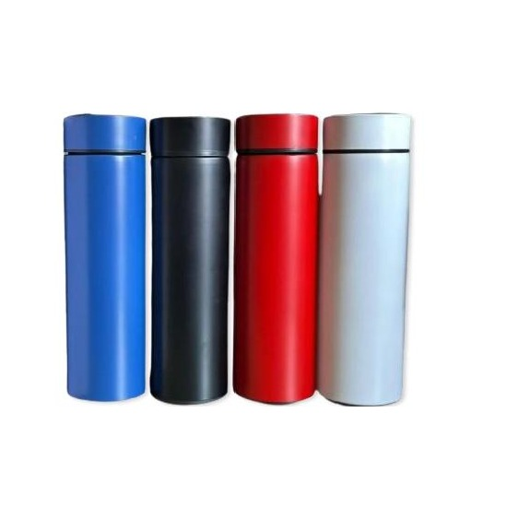  Vacuum Mug with Temp Display  304-Grade Stainless Steel | 500 ml  304-grade vacuum mug with smart built-in temperature display  ₹125 |  | Item No. 18  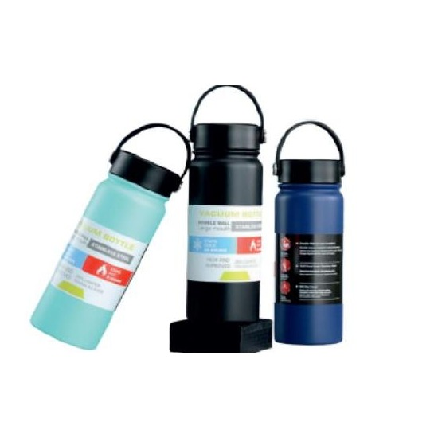  Double Wall Bottle with Strap  304-Grade Stainless Steel | 800 ml  304-grade double-wall insulated bottle with adjustable carry strap  ₹330
Item No. 19  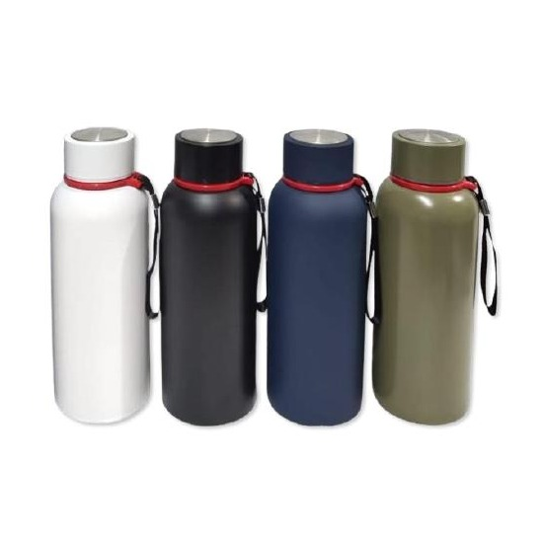  Double Wall Bottle with Strap  304-Grade Stainless Steel | 500 / 800 ml  304-grade double-wall insulated bottle with carry strap, two size options  ₹325 |  | Item No. 20  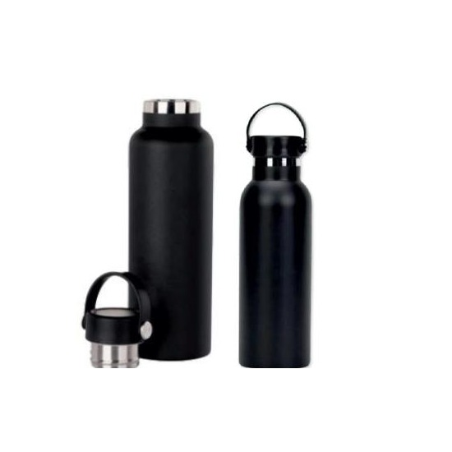  Double Wall Insulated Bottle  Stainless Steel | 750 ml  Double-wall stainless steel bottle, keeps drinks hot or cold for hours  ₹330
Item No. 21  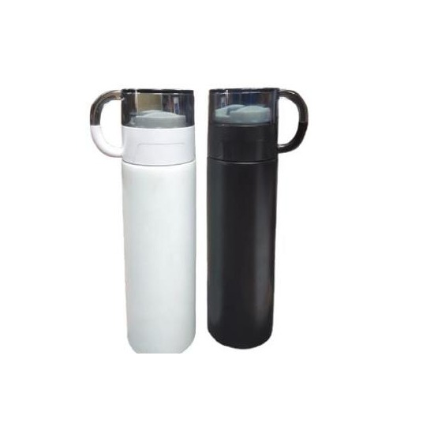  Eco Vacuum Flask with Tea Cup  Stainless Steel | 500 ml  Eco-friendly vacuum flask bundled with a matching tea cup  ₹220 |  | Item No. 22  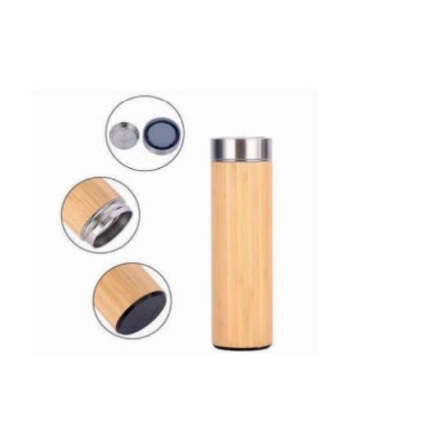  Bamboo Thermos Vacuum Flask  Bamboo & 304 Stainless Steel | 450 ml  Natural bamboo-wrapped thermos with 304 stainless steel vacuum liner  ₹240
Item No. 23  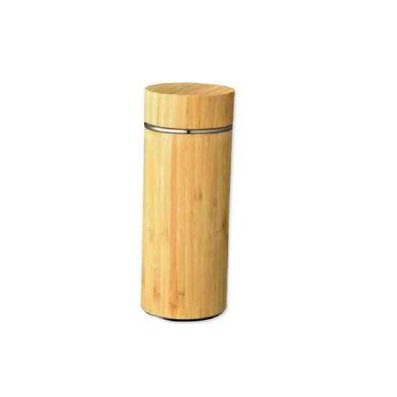  Double Wall Bamboo Thermos Bottle  Bamboo & 304 Stainless Steel | 500 ml  304 double-wall thermos bottle with handcrafted bamboo exterior  ₹275 |  | Item No. 24  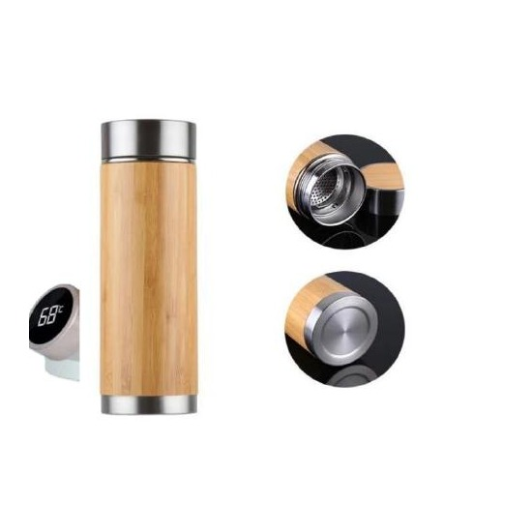  Bamboo Vacuum Insulated Bottle  Bamboo | 450 ml  Eco-friendly all-bamboo vacuum insulated bottle, natural finish  ₹275
Item No. 25  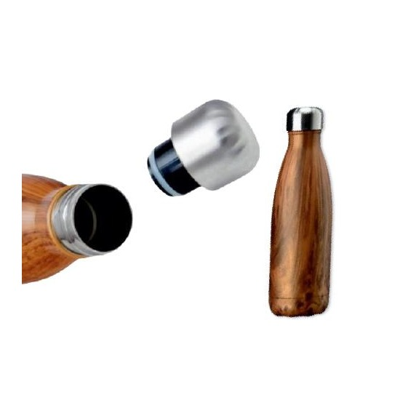  304 Double Wall Thermos Bottle  304-Grade Stainless Steel | 500 ml  304-grade double-wall thermos bottle, keeps drinks at ideal temperature  ₹285 |  | Item No. 26  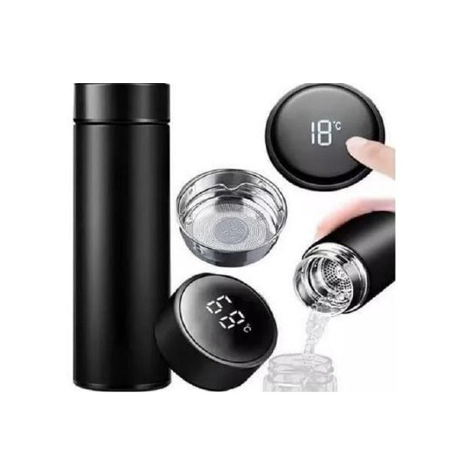  Smart Temperature Display Bottle  Stainless Steel | 500 ml  Stainless steel bottle with real-time temperature indicator display  ₹125
Item No. 27  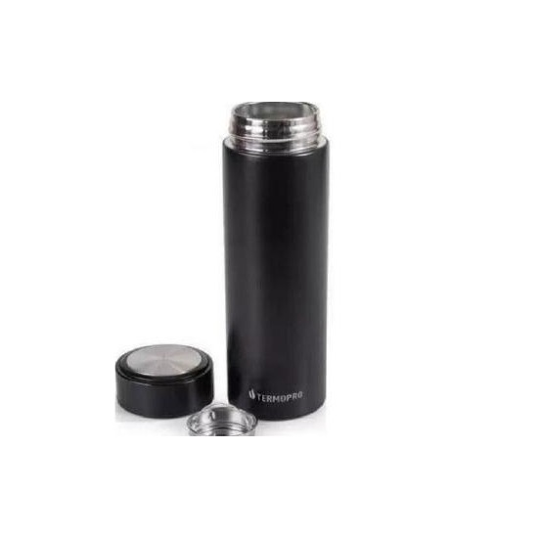  Temperature Bottle (No Display)  Stainless Steel | 500 ml  Simple hot & cold stainless steel temperature bottle, clean design  ₹125 |  | Item No. 28  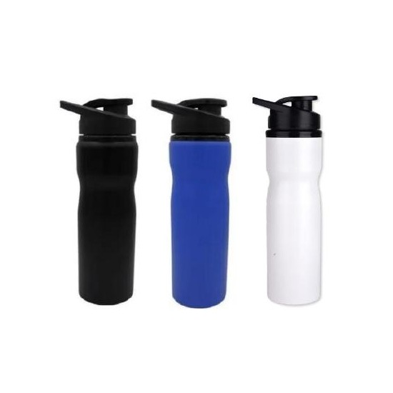  Stainless Steel Sipper Bottle  Stainless Steel | 750 ml  Stainless steel sipper bottle with convenient drinking spout lid  ₹120
Item No. 29  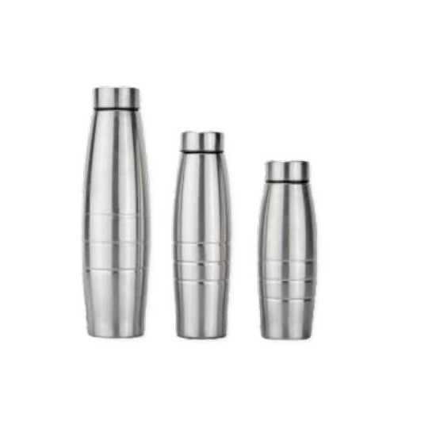  Single Wall Stainless Steel Bottle  Stainless Steel | 1000 ml  Classic single-wall stainless steel bottle, lightweight and durable  ₹95 |  | Item No. 30  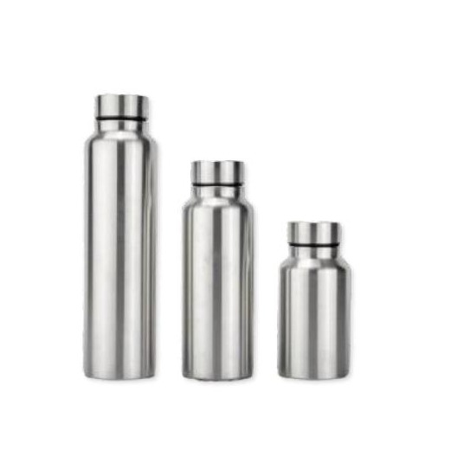  Single Wall Stainless Steel Bottle  Stainless Steel | 500 / 750 / 1000 ml  Single-wall stainless steel bottle available in three capacity options  ₹95
Item No. 31  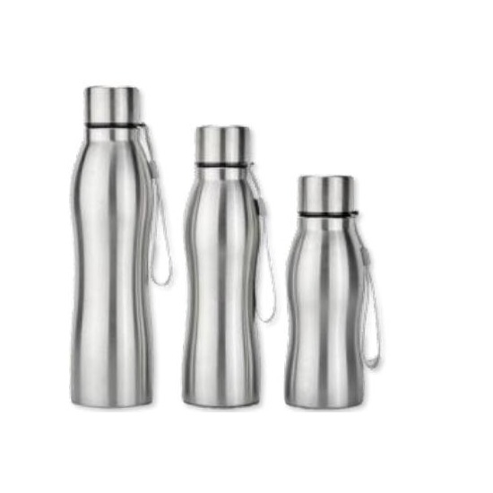  Single Wall Stainless Steel Bottle  Stainless Steel | 500 / 750 / 1000 ml  Functional single-wall bottle with loop carry strap, three sizes  ₹95 |  | Item No. 32  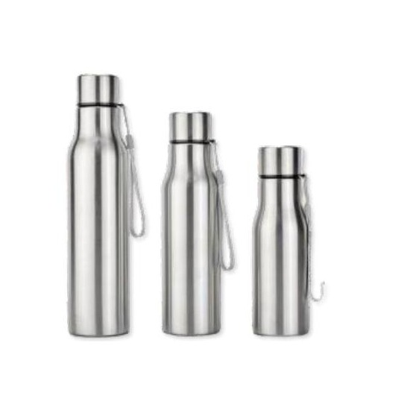  Stainless Steel Single Wall Bottle  Stainless Steel | 1000 ml  Everyday lightweight single-wall stainless steel water bottle  ₹95
Item No. 33  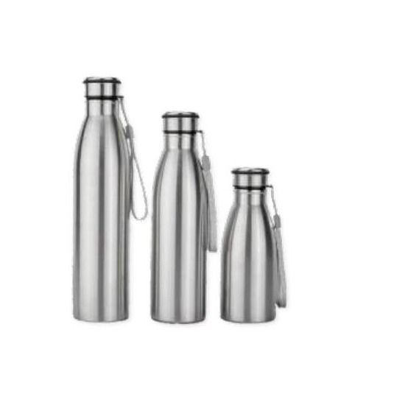  Single Wall Water Bottle  Stainless Steel | 500 / 750 / 1000 ml  Clean minimalist single-wall bottle in three convenient capacities  ₹95 |  | Item No. 34  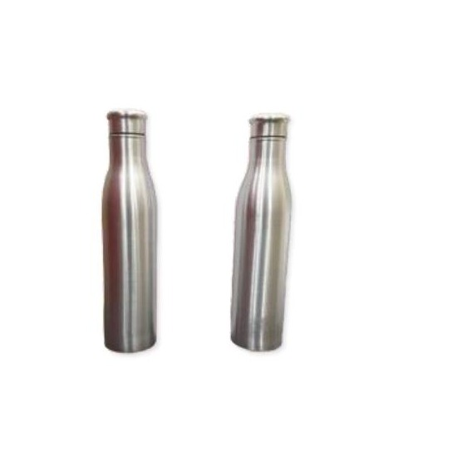  Single Wall Water Bottle  Stainless Steel | 1000 ml  Slim-profile single-wall bottle, ideal for everyday hydration  ₹95
Item No. 35  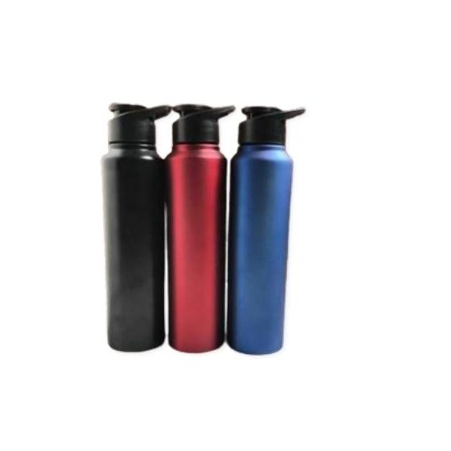  Single Wall Bottle – Large  Stainless Steel | 1000 ml  Large single-wall stainless steel bottle with premium matt finish  ₹135 |  | Item No. 36  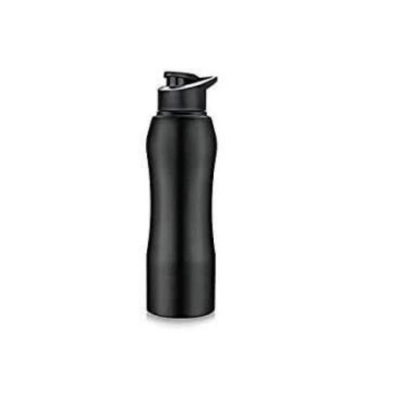  Single Wall Bottle  Stainless Steel | 750 / 1000 ml  Versatile single-wall bottle with stylish design, two size options  ₹135
Item No. 37  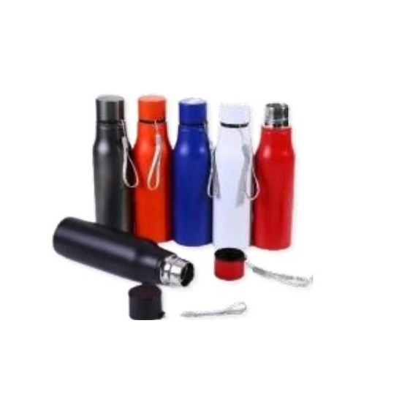  Single Wall Bottle – Compact  Stainless Steel | 750 ml  Compact single-wall stainless steel bottle, perfect daily carry  ₹100 |  | Item No. 38  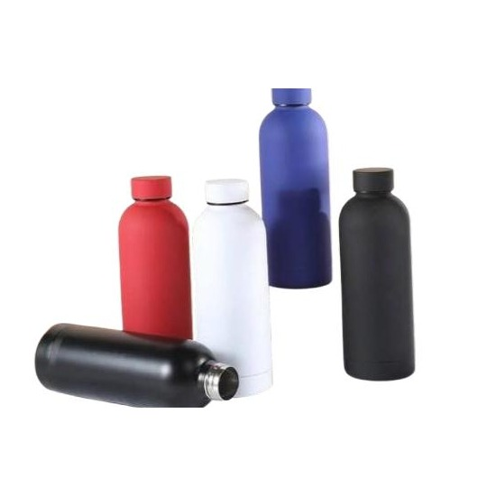  Premium Single Wall Bottle  Stainless Steel | 750 ml  Premium-finish single-wall stainless steel bottle, bold color options  ₹240
Item No. 39  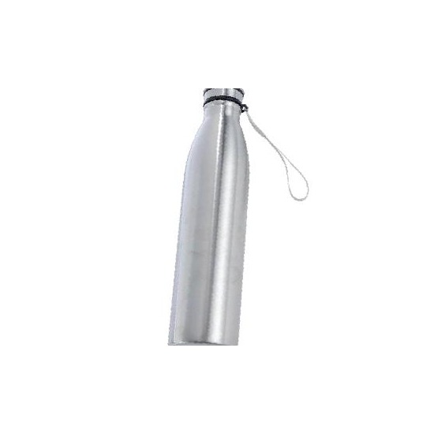  Everyday Single Wall Bottle  Stainless Steel | 750 ml  Classic everyday single-wall stainless steel water bottle  ₹95 |  | Item No. 40  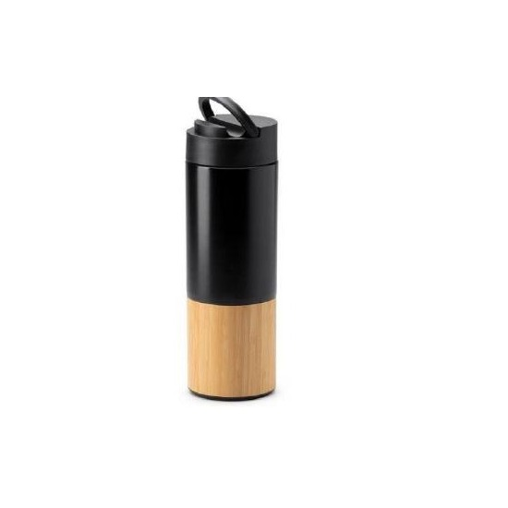  Stainless Steel & Bamboo Bottle  Bamboo & Stainless Steel | 500 ml  Stainless steel bottle with natural bamboo accent lid and body band  ₹245
Item No. 41  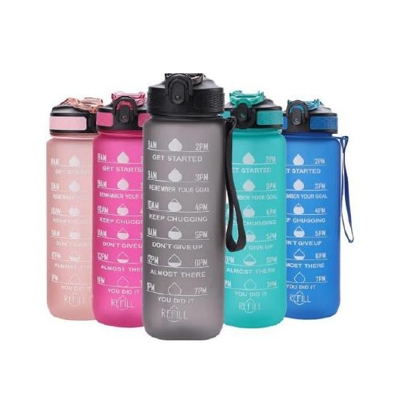  Motivational Tracker Bottle  Tritan Plastic | 900 ml  Hourly motivation tracker bottle, frosted finish, multiple pastel colors  ₹120 |  | Item No. 42  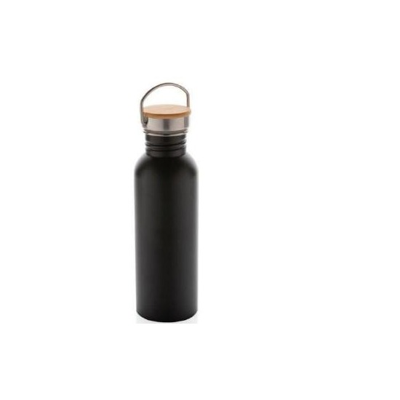  Bottle with Wooden Lid & Handle  Stainless Steel & Wood | 750 ml  Stainless steel bottle with natural wooden lid and carry handle  ₹185
Item No. 43  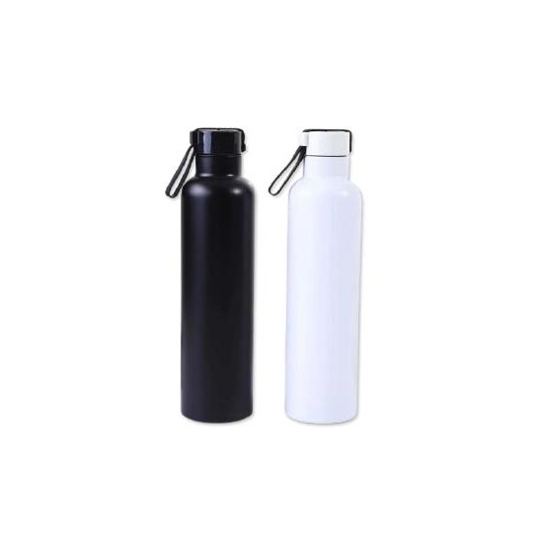  Silicon Handle Bottle  Stainless Steel | 800 ml  Stainless steel bottle with soft silicone grip handle for comfort  ₹260 |  | Item No. 44  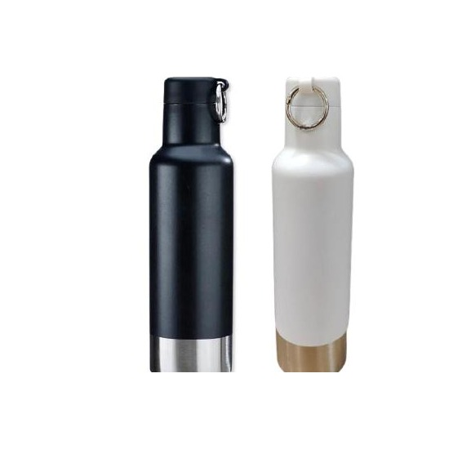  Slim Single Wall Bottle  Stainless Steel | 500 ml  Slim single-wall stainless steel bottle, elegant matte color finish  ₹240
Item No. 45  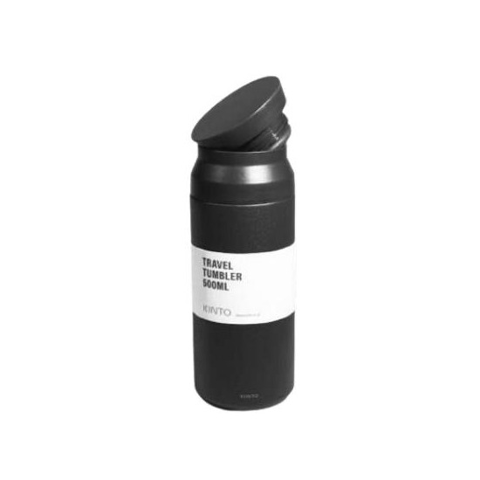  Premium Single Wall Bottle  Stainless Steel | 500 ml  Premium single-wall bottle with refined design, available in colors  ₹250 |  | Item No. 46  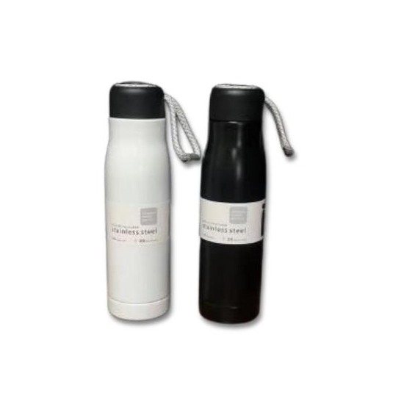  Rope Handle Water Bottle  Stainless Steel | 550 ml  Stainless steel bottle with braided rope carry handle, travel-ready  ₹170
Item No. 47  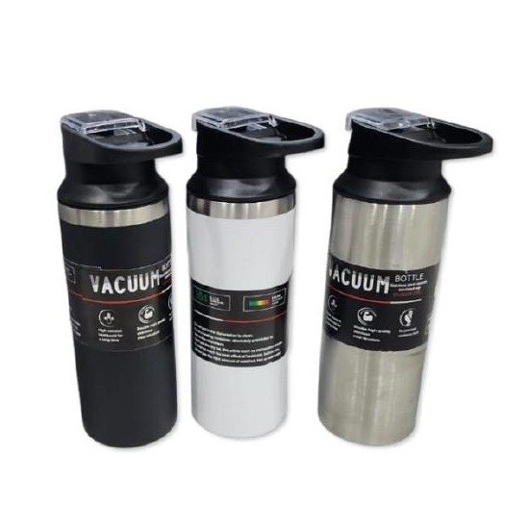  Loop Handle Water Bottle  Stainless Steel | 500 ml  Trendy stainless steel bottle with loop handle, ideal for active use  ₹240 |  | Item No. 48  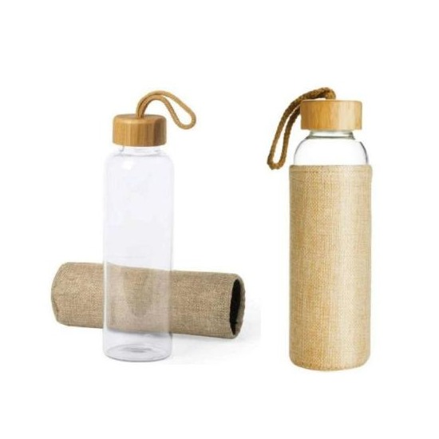  Borosilicate Glass Bottle  Borosilicate Glass | 750 ml  Clear borosilicate glass bottle for a pure, clean drinking experience  ₹135
Item No. 49  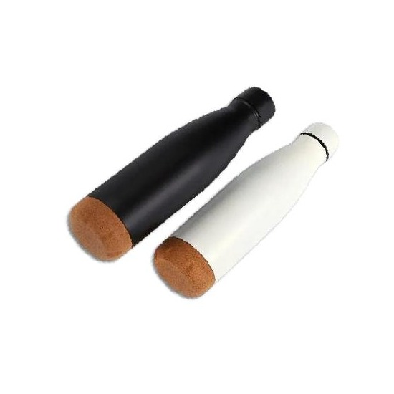  Cola Bottle with Cork Stopper  Stainless Steel | 500 ml  Hot & cold cola-style stainless steel bottle with natural cork stopper  ₹275 |  | Item No. 50  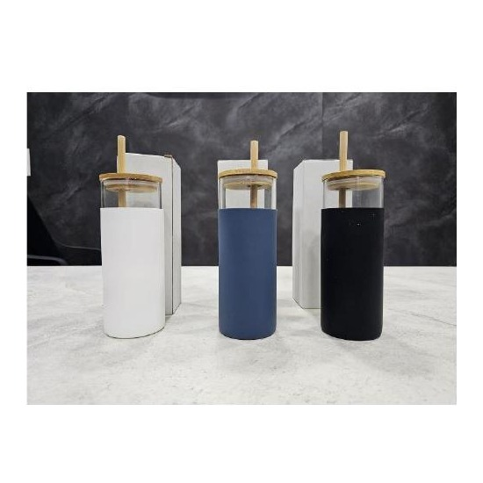  Stainless Steel Sipper Bottle  Stainless Steel | 500 ml  Compact stainless steel sipper bottle with easy-flow drinking spout  ₹125
Item No. 51  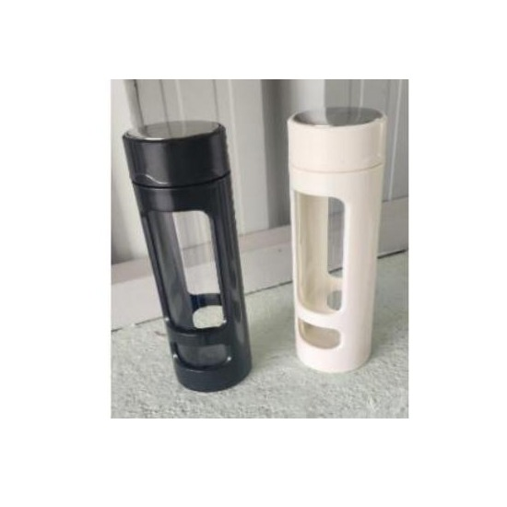  Borosilicate Glass Bottle  Borosilicate Glass | 750 ml  Elegant clear glass bottle with protective sleeve, pure-taste design  POA |  | Item No. 52  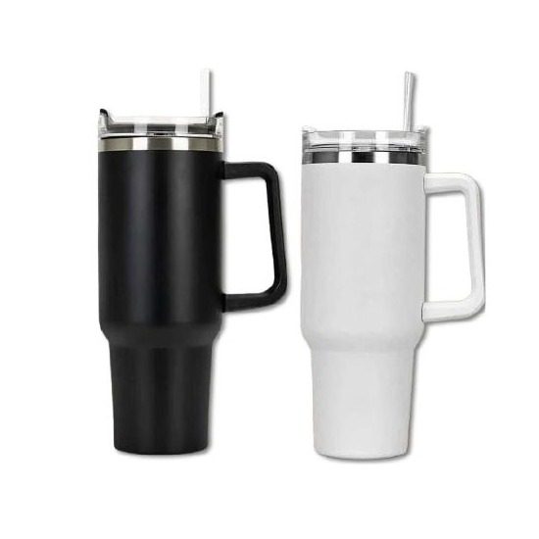  Large Capacity Stainless Bottle  Stainless Steel | 1200 ml  Large-capacity stainless steel bottle for extended hydration on the go  POA

Thank you
for considering Robust Gifting

All items available for custom branding.
Minimum order quantities and lead times on request.
Prices are exclusive of 18% GST. Valid 2026.

